OVERVIEW
The City of Lynn is the 9th largest municipality in Massachusetts and the largest city in Essex County. Situated on the Atlantic Ocean, less than 10 miles north of Boston. Lynn has a population of 94,299 and about 55.4% of its housing units are renter-occupied. Lynn has a long and notable history of shoe making and in the late 1800’s, the inventor of the shoe-lasting machine, Jan Matzeliger not only revolutionized the shoe industry but made the city the "shoe capital of the world.” Lynn is also well known as the location of the first jet engine built in the U.S. as General Electric (GE) formed in the city and continues a presence to this day.

Schools

Lynn Woods Elementary School (Grades K – 5)
Great Schools Rating: 8/10

Shoemaker Elementary School (Grades PK – 5)
Great Schools Rating: 6/10

Edward A. Sisson Elementary School (Grades K – 5)
Great Schools Rating: 6/10

Pickering Middle School (Grades 6 – 8)
Great Schools Rating: 5/10

Lynn English High School (Grades 9 – 12)
Great Schools Rating: 3/10

Classical High School (Grades 9 – 12)
Great Schools Rating: 2/10

Lynn Vocational Technical Institute (Grades 9 – 12)
Great Schools Rating: 3/10

High School Graduation Rate
Lynn English High School | 70.0%
Classical High School | 82.5%
Lynn Vocational Technical Institute | 89.5%
Massachusetts | 88.0%

Data Sources: GreatSchools.org; MA Dept. of Elementary & Secondary Education District Profiles

Transportation
Lynn has a stop on the Newburyport/Rockport Line of the MBTA Commuter Rail, as well as the River Works stop, which is for GE Aviation employees only. Lynn is also a major bus transfer point serving 11 MBTA bus routes in the North Shore region, including routes leading to Salem, Marblehead, Wonderland, and the Liberty Tree Mall as well as downtown Boston. Approximately 67% of Lynn resident workers use a private vehicle for commuting.

Community safety
In 2016, the City of Lynn’s violent crime rate was 95% higher than the national average and 105% higher than the Massachusetts average. The property crime rate was 15% lower than the national average and 33% higher than the Massachusetts average.

Data Source: www.cityrating.com/crime-statistics

DEMOGRAPHICS
Poverty Rate: 17.3%

Percent of population that speaks a language other than English at home: 53.0%

Race | %
White | 48.1%
Some other race | 24.2%
Black/African American | 13.5%
Asian | 7.5%
Two or more races | 6.3%
American Indian and Alaska Native | 0.4%
Native Hawaiian and Other Pacific Islander | 0.0%

Age Group | %
Under 5 | 7.5%
Age 5-17 | 16.6%
Age 18-64 | 64.2%
Age 65 and older | 11.7%

Data Source: American FactFinder, U.S. Census Bureau

*Please note that not all parts of Lynn are SNO Mass Opportunity Areas. See map on reverse page.

Local Amenities
Lynn is known for its contemporary public art, immigrant population, historic architecture, downtown cultural district, loft-style apartments, and public parks and open spaces, which include the oceanfront Lynn Shore Reservation; the 2,200-acre, Lynn Woods Reservation; and the High Rock Tower Reservation; and Gannon Golf Course. Lynn also is home to the Lynn Museum and Historical Society, the Lynn Memorial Auditorium, Lynn Heritage State Park, the southernmost portion of the Essex Coastal Scenic Byway, and the seaside, National Register-listed Diamond Historic District. There are also many notable shops and restaurants that make Lynn their home; The Blue OX, Rossetti’s, Antique Table, Capital Diner, RFO Sullivan’s, Rolly’s Tavern, Brothers Deli, and Zimman’s fabric store to name a few.

The Lynn Woods Reservation was founded in 1881, the second largest municipal park in the United States, is a 2,200-acre municipal forest park located in Lynn, Massachusetts. The Woods offers over 30 miles of scenic trails for hiking, running, horseback riding, mountain biking and nature walks. Dungeon Rock is a well-loved underground tunnel with a history of pirate lore and treasure seekers. The Rose Garden, Houghton Horticultural Garden, and Amphitheater areas provide more formal settings to explore.

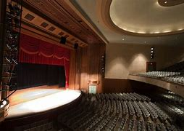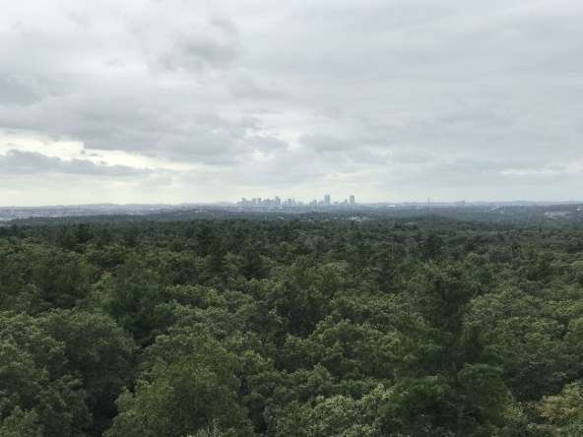
Lynn Memorial Auditorium and Lynn Woods Reservation (Photo Source: Boston.com / All Trails)

MAP

