To: RAFT Agencies
From: Alvina Brevard, Acting Associate Director, Division of Housing Stabilization, Department of Housing and Community Development
Issue Date: 10/13/20
Effective Date: 10/19/20
Expiration Date: To be determined
Re: Interim RAFT Program Guidance
Summary: This document outlines interim RAFT program guidance, including the administration of an increased benefit level for COVID-19 impacted households and changes to application procedures.
Timing
This Interim Guidance is in effect from October 19, 2020, until a new Administrative Plan is issued (likely late October). The new Plan will formally incorporate these and additional changes.
Application and Processing Changes
New Application
DHCD has developed a new paper application, which shall be accepted beginning 10/19/20. RAFT Agencies are expected to post the new application on their websites and make appropriate changes to any online applications (i.e., Cognito) by 10/19/20. Translations will be shared with RAFT Agencies as soon as they are available.
Applicants who have already submitted the prior application are not required to re-submit. The prior application shall also be accepted from new applicants until the new Administrative Plan is issued and new income verification procedures take effect. At that time, applicants will be required to sign the authorization and consent form on the “new” application to permit income verification in other state agency databases.
Specifically, the new application makes the following changes:
- Asks for the landlord contact info in the initial application.
- Photo ID required for head of household only (IDs and birth certificates no longer required for other household members or children).
- Social security number only is required for all household members who have one (no copy of the card/other proof required).
- Authorization and Consent language is consolidated so the applicant and other adult household members each sign only once in the application
- If a client cannot sign or e-sign the actual RAFT application, consent may be provided with a written affirmation over email or letter (to be retained in the client file) if the applicant is either
  - Read the ENTIRE application by a RAA staff person, including the Authorization and Consent, OR
  - Is sent the application for their review.
- Adds additional language directing applicants to MassHire Career Centers. RAFT Agencies must also include this language in application receipts or other confirmations sent to applicants. RAFT Agencies are encouraged to post this language elsewhere as well.
The “Landlord Door” application is forthcoming in future guidance, and is expected before the end of October.
Processing Changes
The following changes are made effective October 19, 2020 to how RAAs should process RAFT applications:
- Income verification remains largely the same until new DUA/DOR verification procedures are put in place in late October:
  - Income documentation is required. Households must provide one month’s worth of consecutive income current within the last 60 days.
  - For benefits up to $4,000, until a new Admin Plan is issued, self-certification in lieu of income documentation, using the existing self-certification form, will only be permitted after the RAA has attempted to collect the documents for a minimum of two weeks.
  - For benefits $4,001 to $10,000, self-certification is not allowed. If there is no income documentation provided after two weeks, applicants seeking the higher benefit level must be told by mail that their application was denied due to incomplete documentation or offer the lower benefit level.
- The prior RAFT screening tool is no longer required. DHCD will monitor applications to ensure that at least 50% of funds are targeted to households with dependents under 21 who may otherwise require EA shelter, based on their reported housing crisis. This is effective immediately and RAAs should not wait until October 19 to stop using the screening tool.
- Applicants for COVID RAFT (<$4k), Upstream RAFT, and Standard RAFT benefits must meet a sustainability requirement. Specifically, the applicant must demonstrate an ability to meet housing costs going forward. This could include, but is not limited to:
  - Sufficient income currently to cover rent, mortgage, or other housing costs.
  - Plan for co-housing or finding a roommate to share rent with others.
  - In the RAAs best judgment, there is a realistic plan to secure employment before the end of RAFT stipends.
  - Other plans which, at the RAFT Agency’s discretion, suggest the tenancy can be maintained.
- Only AMI bracket must be entered into HAPPY; income source and amount are NOT required to be entered into HAPPY anymore. However, RAFT Agencies MUST retain the application documenting income source and amount.

Benefit Level
Starting on October 19, 2020, RAFT programs will have new benefit levels. RAAs have discretion to guide applicants to the appropriate RAFT (or other) program based on tenant need and landlord willingness to negotiate. The new maximum benefit level is $10,000 for households who have one of the five eligible housing crises (Upstream rent arrears-market, Upstream rent arrears-subsidized, Court eviction-market, Court eviction-upstream, Inability to pay future market rent) AND a financial hardship caused or exacerbated by COVID-19. The COVID-19-related financial hardship will continue to be self-certified by the applicant on the application.
Not all COVID-19-affected households will qualify for the new $10,000 maximum benefit level. Most housing crises will still fall under the $4,000 maximum benefit level, but renter households with rent arrears or an inability to pay future rent will qualify for a benefit of up to $10,000 if their landlord agrees to the stipulations outlined below.
All households are limited to a maximum of $10,000 in a 12-month period combined between any type of RAFT, ERMA, and HomeBASE. This means that if a household received $4,000 in the last 12 months through Standard, Upstream, or COVID RAFT, they may be eligible for up to another $6,000 if they have a COVID-19-related hardship and meet one of the five eligible housing crises outlined below.
As with existing RAFT and HomeBASE rules, the maximum benefit is calculated on a “rolling” basis. Some households who already received $4,000 in RAFT in the last 12 months may still be scheduled for another $10,000 in COVID RAFT, so long as the total benefit amount received in any rolling 12-month period does not exceed $10,000. (Example: Tenant received $4,000 on 12/1/2019. Tenant could receive $6,000 in arrears on 11/1/2020, and then receive stipends starting on 12/1/2020, not to exceed $4,000 before 11/1/2021.)
The chart below outlines the types of COVID RAFT that households may receive and the allowable housing crises that apply to each type.
The increased benefit level is available for all payments issued on or after October 19, 2020, regardless of when the application was submitted. RAAs should review pending applications to determine if any applications that were submitted prior to October 19 require assistance above $4,000.

Terms | COVID RAFT | RAA Facilitated COVID RAFT  (Available after 10/19/20) | Mediated COVID RAFT  (Available after 10/19/20)
Benefit amount | Up to $4,000 | $4,001 to 10,000 | Up to $10,000
Tenant Commitment | Must demonstrate can sustain paying rent or mortgage after RAFT payment ends | Pays at least 30% of income to forward rent or payment plan for arrearage repayment. Income is set at time of application; no income redeterminations during the RAFT agreement period.  Tenant may pay more than 30% of income. However, as a guideline, recommend tenant does not pay more than 50% of income to forward rent, but RAA may determine if there are extenuating circumstances where paying more than 50% of income to rent is sustainable for the household. | Court or Community Mediation decides what tenant pays to repayment of arrearages and forward rent.
Landlord Commitment | Cannot evict for any month that the RAFT payment covers (arrears or stipends) | Cannot evict for arrears.  Must enter into a RAFT agreement that will sustain tenancy for 6 months from first RAFT payment or until June 2021 if school-aged children in household, whichever date is later. If the lease is ending in less than six months, either it should be extended to last at least six months or the applicant should only be considered for a RAFT benefit under $4,000.  May need to forgive portion of arrears or reduce contract rent in order to meet 6-month tenancy requirement (if $10K doesn’t cover 100% of arrears plus 6 forward months of rent with RAFT stipends). In addition, there may be a locally-funded rental assistance program, that may be layered on top the RAFT benefit. | Court or Community Mediation decides what concessions Landlord makes on arrears or forward rent.  If RAFT benefit is more than $4,000, landlord must enter into an agreement that will sustain tenancy for 6 months from first RAFT payment or until June 2021 if school-aged children in household, whichever date is later. If the lease is ending in less than six months, either it should either be extended to last at least six months or the applicant should only be considered for a RAFT benefit under $4,000.
Preservation  Requirement | Sustainability requirement reinstated; no landlord guarantee of months preserved. | Landlord commits to no eviction for 6 months or until June 2021
Income verification during Interim Guidance | Existing practice (paystubs, etc) OR self-certification after 2 weeks of attempts | Existing practice (paystubs, etc). No self-certification. | Existing practice (paystubs, etc). No self-certification if accessing over $4,000.
Eligible housing crises | - Upstream rent arrears (market)  - Upstream rent arrears (subsidized)  - Upstream mortgage arrears  - Court eviction (market)  - Court eviction (subsidized)  - Inability to pay future market rent  - Inability to pay future mortgage  - Doubled up  - Health/safety  - Foreclosure  - Overcrowding  - Domestic violence  - Fire/flood/natural disaster  - Utility shutoff  - Other crisis | - Upstream rent arrears (market)  - Upstream rent arrears (subsidized)  - Court eviction (market)  - Court eviction (subsidized)  - Inability to pay future market rent | - Upstream rent arrears (market)  - Upstream rent arrears (subsidized)  - Court eviction (market)  - Court eviction (subsidized)  - Inability to pay future market rent

Terms | Standard RAFT | Upstream RAFT
Benefit amount | Up to $4,000 (same as current practice)
Tenant Commitment | Tenant commits to meeting lease terms (same as current practice)
Landlord Commitment | Cannot evict for rent paid via RAFT (same as current practice)
Preservation  Requirement | Sustainability requirement reinstated; no landlord guarantee of months preserved
Income verification during Interim Guidance | Existing practice (paystubs, etc) OR self-certification after 2 weeks of attempts
Eligible housing crises | - Court eviction (market)  - Court eviction (subsidized)  - Doubled up  - Health/safety  - Foreclosure  - Overcrowding  - Domestic violence  - Fire/flood/natural disaster  - Utility shutoff  - Other crisis | - Upstream rent arrears (market)  - Upstream rent arrears (subsidized)  - Upstream mortgage arrears
Summons required for payment of rent arrears? | Yes | No

To aid in calculating the benefit, DHCD has adapted the Owner Contract. The owner contract will be sent out by 10/15.
Changes Forthcoming
The following changes will occur in the coming weeks but are not in effect now. When they do, DHCD will issue new permanent guidance via a revised Admin Plan.
- Income verification through the Department of Unemployment Assistance and the Department of Revenue and eligibility verification for MassHealth and DTA benefits
- Dedicated landlord application for owners of up to 20 units of housing (“Landlord Door”)

Appendix 1: RAFT Program Decision Tree

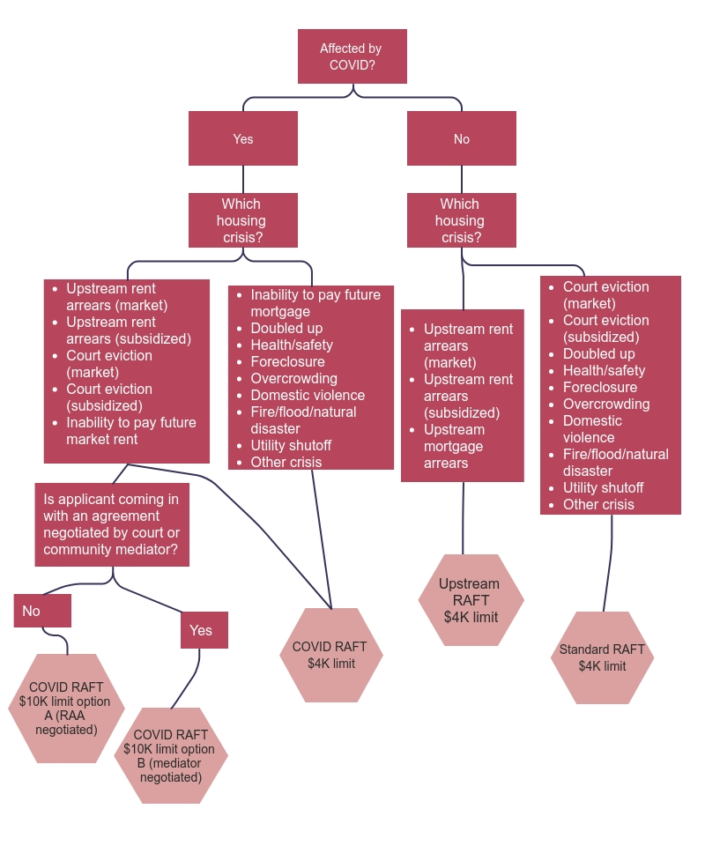

Your local MassHire Career Center can help you with job search and connect you to other services to improve skills, land a job or develop a long-term career path. MassHire Centers are open for virtual services, so please call the one closest to you to enroll in a Career Center Seminar. The list of MassHire Centers across the state can be accessed at https://www.mass.gov/how-to/find-a-masshire-career-center. You can also search and match to more than 150,000 open jobs online, utilize online tools to assess your skills, explore careers, sign up for scheduled virtual events, and manage your job search in JobQuest. You do not need to call a MassHire Career Center to register in the system. Go to www.mass.gov/jobquest to get started.
A list of approved mediators is forthcoming.

